Research Methods 205

Winter 2024

Sections 20 and 21

Your Name:

______________________

If you are taking the exam remotely or on a laptop in the classroom,  
upload the completed exam to Canvas at the end of the exam period.

If you are completing the exam on paper,  
 hand the completed exam to the TA at the end of the exam period.

This exam is new for this class quarter, as always.  
If you think there is a typo or something written unexpectedly unclearly, please ask the TA or professor for clarification.  
 Necessary corrections will be posted in class and on zoom.

There are a total of 20 question elements on this exam. Each is worth an equal 5 pts. Some of the questions are more challenging even though the point values are the same. If you find yourself stuck on a difficult question, make sure to answer all the easy questions. If you are unclear about the answer, explain what you think the relevant issues are so that we can identify your knowledge of the content and give partial credit.

Do not leave questions blank!

Even if you are running short of time, show us your thought process related to what you have learned about research methodology.

If you are taking the exam on paper and are running out of space, use the back sides of exam pages for additional room to explain your answers.

**Question 1.** *Earworms* describe the phenomenon of hearing recurring musical tunes that stick in your mind. Scullin et al. (2021) studied the impacts of self-reported earworms and listening to music on the amount of sleep people get at night.

A 2x2 replication of their study was run by Dr. P in which participants were assigned to one of two music conditions: music before bed or no music before bed. Further, participants were then split into two groups by whether or not they reported having an earworm before bed. The results for Dr. P’s study are shown below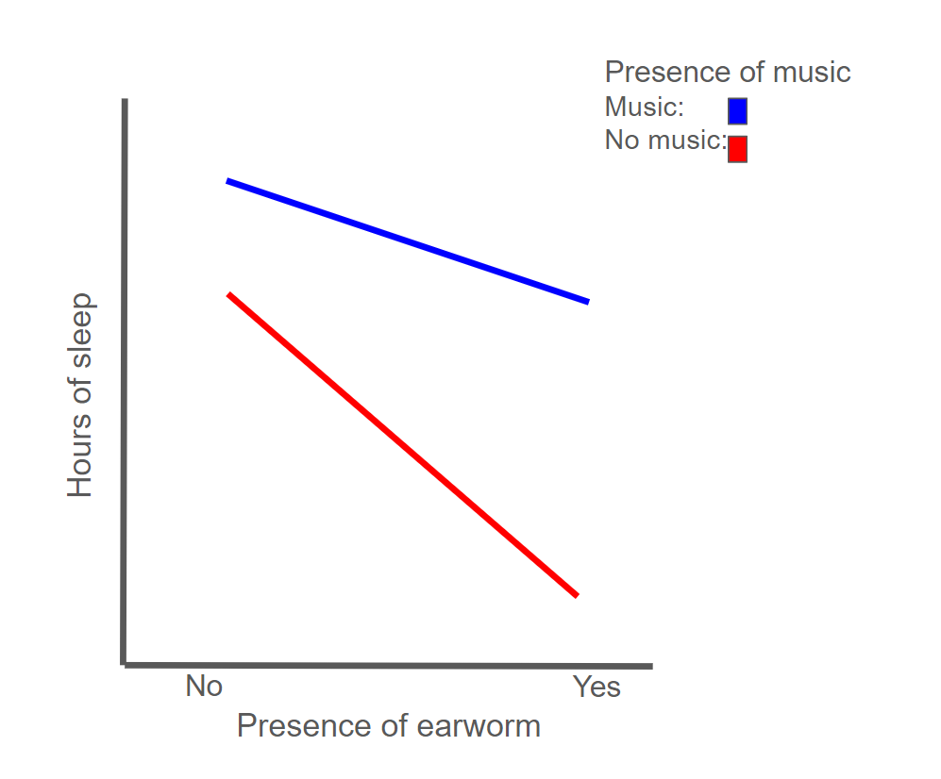

1a. What are the independent variables in this experiment?

1b. What is the dependent variable in this experiment?

1c. Hypothetical results from two-way ANOVA are shown below. Please describe the main effects found in Dr. P’s study in standard APA format.

|  |  |  |  |  |  |
| --- | --- | --- | --- | --- | --- |
| Effect | DFn | DFd | F | p | p<.05 |
| Earworms | 1 | 97 | 3.28 | 0.034 | * |
| Music | 1 | 97 | 4.57 | 0.009 | ** |
| Earworms x Music | 1 | 97 | 8.91 | 2e-5 | *** |

1d. Report the interaction in the results from this study and provide an interpretation of this finding.

1e. The main effect of music on sleep puzzled the researchers because a previous study had found the opposite effect, that music delayed sleep and led to fewer hours of sleep total. In this study, the music was always the same piece of instrumental performance without any lyrics. The prior work varied music across genres, including music with lyrics. State a possible hypothesis regarding how different kinds of music might affect sleep that would explain both results.

1f. Dr. P finds that his data is fairly clustered, with some participants sleeping much longer than others. As part of the study protocol, data were also collected about a measure of overall life stress in participants using the Perceived Stress Scale which provides a value between 0 and 40 with higher values indicating greater life stress. Dr. P suspects that participants with higher stress may get less sleep and wants to examine this relationship in the experimental data. To assess this, which statistical method would he need to use? What rough estimate of this statistic would reflect a moderately strong relationship?

1g. When Dr. P first looked at the above relationship (1g), he found a group of data points that made the association between stress and hours of sleep weaker. To address this, one of his colleagues suggested removing this group of data all together, so the result could be seen more clearly. What is this colleague suggesting and why is it a violation of research ethics?

**Question 2.** Prior studies have suggested that there are sex differences in spatial language among preschool children aged 34-46 months, with boys producing more spatially related words like: in, on, above, or under (Pruden & Levine, 2017). To replicate their findings, Prof. J recruited 90 preschool children (half boys and half girls). Each participant was shown a photo of the interior of a room and were asked to describe these objects in the room. Their response was scored as to whether it included a spatially related word or not.

2a. What element is acting like the independent variable in this study?

2b. What is the dependent variable?

2c. What statistical tool would be used to evaluate whether the IV is reliably affecting the DV?

2d. Is Prof J.’s replication study technically an experiment? Explain why or why not?

2e. In a follow-up study, researchers examined the effect of prosocial talk (e.g. “You did a great job building that!”) from a parent on a child’s subsequent use of spatial language. To measure this effect, the measure of spatial language use was extended to count the total number of spatially related words used describing 24 photographs of interior rooms. To design an independent variable for this study based on prosocial talk, what are two extraneous variables that will need to be considered?

2f. Outline a 2 x 2 factorial design that studies the effect of parent prosocial talk (from 2e) and sex (from the original study) on spatial speech production.

2g. Speculate results for this study (in 2f) that include a reliable interaction and at least one reliable main effect. Fully describe the interaction term and what it says about how the independent variables affect the dependent variable.

**Question 3.** To study factors that influence lung cancer risk, researchers recruited 250 lung cancer patients to complete a study with an in-person survey about lifestyle behaviors to identify possible relationships for future study.

3a. Based on open-ended questions in the survey, they used *ground theory* to identify and summarize commonalities between patients’ eating habits and outcomes of their cancer treatment. Is this an example of qualitative or quantitative research? Explain your answer.

3b. In the initial draft of the survey, participants were asked how much they agreed with the statement “I usually sleep early and exercise regularly”. Point out the problem with this item and explain how it should be revised.

3c. Considering only a small portion of the general population has lung cancer, the researchers decide to draw their sample from medical institutes that have cancer treatment centers in each area. Using cancer centers as clusters, briefly describe how the researchers can use cluster sampling to recruit participants. For in-person surveys, what advantage does cluster sampling have compared to simple random sampling?

3d. Another research group gathered health data of lung cancer patients from a large scale survey found that increasing body mass index (BMI) is inversely associated with the severity of symptoms during treatment. BMI is a measure related to body weight where people with BMI < 18.5 are classified as underweight; people with BMI > 25 are classified as overweight. Explain why correlation does not imply causation, by giving an example of directionality problem and an example of the third variable problem.

3e. After evaluating the data in 3d, it was discovered that some overweight patients refused to answer the survey because they were embarrassed about their weight. What type of sampling bias should the researchers be worried about and how might this affect the interpretation of the relationship observed?

3f. If BMI can influence the quality of cancer survivorship this indicates the importance of integrating weight management as part of cancer treatment plans. What ethical issues would need to be addressed if an intervention was aimed at improving BMI as part of a lung cancer treatment plan?